1. Get something to run or fail

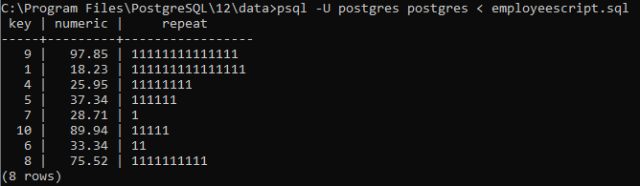

1. Script that runs on first error:

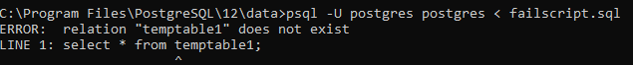

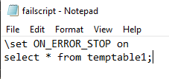

1. Using psql variables



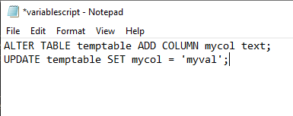

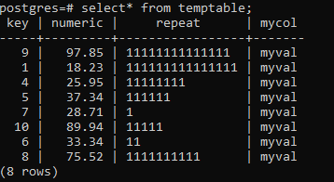

1. placing query output into psql variables

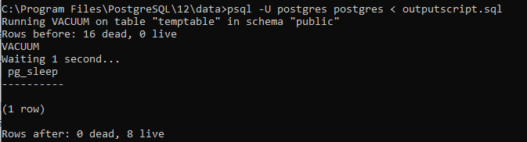

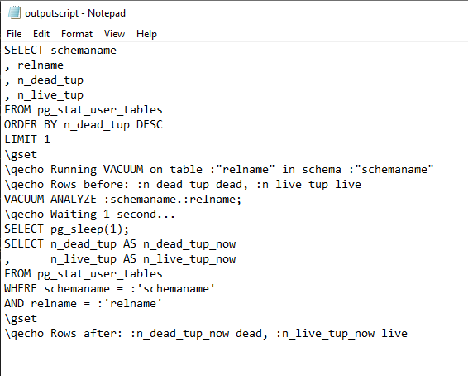

1. write a conditional psql script

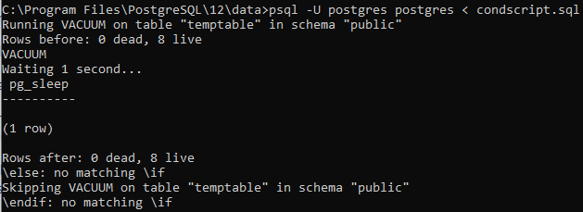

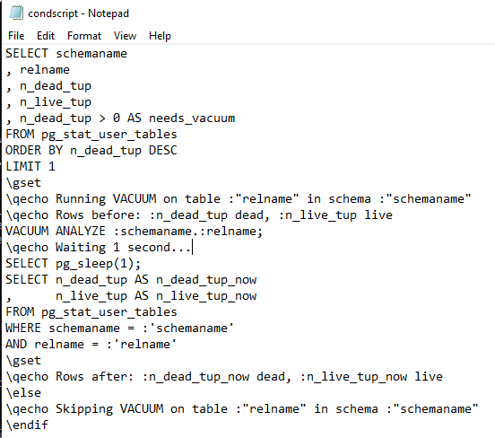

1. investigating a psql error

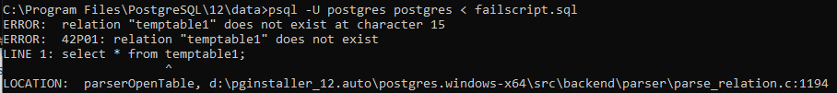

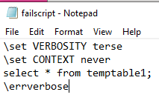

1. performing actions on many tables

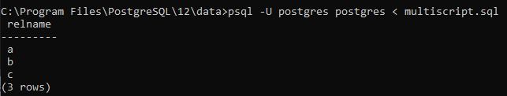

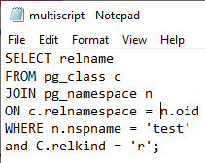

1. adding/removing columns of a table



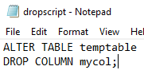

1. changing the data type of a column



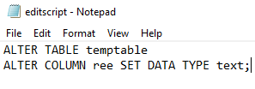

1. changing the definition of a data type



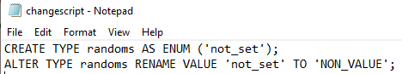

1. adding/removing schemas



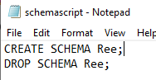

1. adding/removing tablespaces



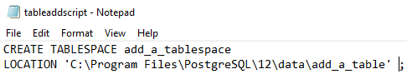

1. moving objects between schemas



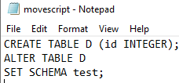

1. moving objects between tablespaces



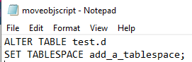

1. accessing objects in other PostgreSQL databases



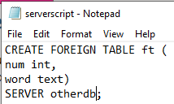

1. accessing objects in other foreign databases

Can’t download oracle without causing computer blocking it.



1. updating views



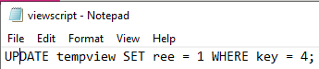

1. using materialized views



